

Project Report

Plant Palace Web Portal

Contents

Case Study 3

1. Definition of the Problem 3
2. Requirement Analysis 4
3. Design Phase 5
4. Architecture of Website 6
5. Evaluation/Testing 7
6. Project Tracking and Monitoring Activities 7
7. Documentation Section 7
8. Source Code 7
9. User Guide 7

V 1.0 Aptech Ltd

# Case Study

Plant Palace was founded according to their simple premise—plants make us happier and healthier humans. They have changed the way people think about buying plants since 2019. They were one of the love-environment online plant shop and they have delivered over 2 million plants to 500,000 happy customers.

Due to recent demands of online shopping, they supply free delivery for every order over £50 of any customer within the country. As a team of professionals, they understand what clients want and deliver the best results to clients.

Plant Palace delivers a new concept of gardening to young people that plants are not only helped in creating the green environment, but also relieving stresses and designing aesthetic appeal. Their aims are to engage in gardening as a hobby or lifestyle and bring diverse plant options to their customers.

### Proposed Solution

Design a marketing Web portal to display the products and services to the customers is one of the solutions to the plant nursery.

The Plant Palace Website serves as an e-commerce as well as informational platform where users can browse and purchase various plants. The Website will also provide categories for different types of plants, allow users to search for specific plants, and offer sorting and filtering options. Moreover, the information about each plant species will be displayed in detail, including origin country, scientific name, watering cycle and humidity.

When a potential customer visits the plant nursery website, he or she will be able to view the showcase of their extensive collection and detailed information. This type of informational Website as well as an e-commerce Website provides a user interface of browsing and purchasing various plants for the customers.

# Definition of the Problem

In the case of Plant Palace as well as plant nursery and e-commerce website, queries of products and services can be one or all of the following:

* + 1. How to design a marketing website to bring the plant nursery message to the customer?
    2. What information should be displayed about each type of plants?
    3. Will the green message increase in the marketplace?
    4. Will the users be able to contact Plant Palace whose order via the website?
    5. Will any customers be able to contact Plant Palace after deciding to buy wholesale plants?

After consulting several IT companies and considering of the budget constraints, the management of **Plant Palace** has decided to launch the marketing website as a Single Page Responsive Web application. Hence, the project will use HTML5, CSS3, JavaScript, Figma Toolkit, Geolocation API, Web Storage, AngularJS, and Bootstrap 5 libraries from getbootstrap.com, and JSON or other HTML editors to build the User Interface. Moreover, this Web portal will be a responsive and visually appealing Website to be used by individuals.

V 1.0 Aptech Ltd

# Requirement Analysis

This phase consists of following:

### List of inputs to the system

### List of outputs expected from the system

### Overview of processes involved in the system

### Hardware and software required for implementing the project

### Customer’s acceptance criteria for the project

For example, in the **Plant Palace** portal project, the objective would be to:

* Provide a fast-loading page smoothly redirects.
* Enable customers to look up for the plant species and detailed information about them.

### Inputs provided by the client:

* Inputs to the existing system
* Outputs from the existing system
* Process involved in the application
* Expected delivery dates
* List of deliverables

### Hardware Requirements:

* Intel Core i3 Processor or higher
* 8 GB RAM or higher
* Color SVGA
* 500 GB Hard Disk space
* Mouse
* Keyboard

### Software Requirements:

* Frontend: HTML5, CSS3, Bootstrap (optional), JavaScript, Figma Toolkit, jQuery, AngularJS/Angular 9/ReactJS, and XML
* Data Store: JSON/TXT

V 1.0 Aptech Ltd

### Scope of the work:

Depending on the decision taken by the management regarding the **Plant Palace** portal, following are the requirements based on which the Single Page Application (SPA) needs to be developed:

* A home page for **Plant Palace** websiteportal that will further display menu options for Login/Register, Plants also known as Products, Feedback, About Us, and Contact Us.
* Register/Login will lead to the appropriate page where users can register themselves or log in if already registered.
* The Plants menu when clicked will display a Web page with various species of plants. Moreover, there are a sorting menu which allows customers to sort the plant catalog based on various criteria, such as price, popularity, or alphabetical order and a filter menu that enables the customer to filter the products by types, light, or humidity.
* Feedback menu will display the feedback form that allows the user to share their opinions about the website as well as their products and services.
* About Us page will display the story of Plant Palace and some relevant information.
* Contact Us will show the telephone number, email, address, and a mini map which enables customers to find the best route to visit their store.
* The user can also view Plant Palace blogs of several tips to take care of their plants or sign up to get more information about the plant nursery.

# Design Phase

### Designing the GUI Standards

Designed multiple screens must be created and linked to each other for the **Plant Palace** websiteportal. Each of these screens should have clear and legible fonts, user-interface elements, navigation elements, a consistent look with respect to appearance, and theme used. The Website should not result in any malicious downloads or unnecessary file downloads as well as it is safe to use. The Website should be easy to navigate with clear items and other elements and easy to understand. The Website should operate in a reliably efficient manner. The Website should demonstrate high value of performance through speed and throughput; in simple terms, the Website should be fast to load and page redirection should be smooth. The Website should support large number of users. The Website should be available 24/7 with minimum downtime and should be compatible with latest browsers.

In the case of **Plant Palace** websiteportal, the modules could be for:

* + Registration
  + Login
  + Feedback

V 1.0 Aptech Ltd

# Architecture of Website

Figure 1.1 displays the application architecture.

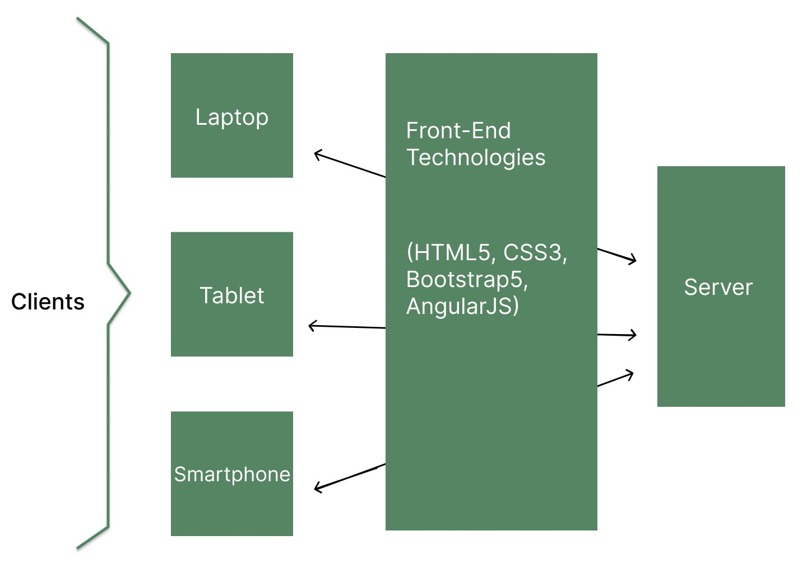

### Figure 1.1: Application Architecture

V 1.0 Aptech Ltd

### Site Map

The figure below shows the Sitemap identified for the Plant Palace web portal.

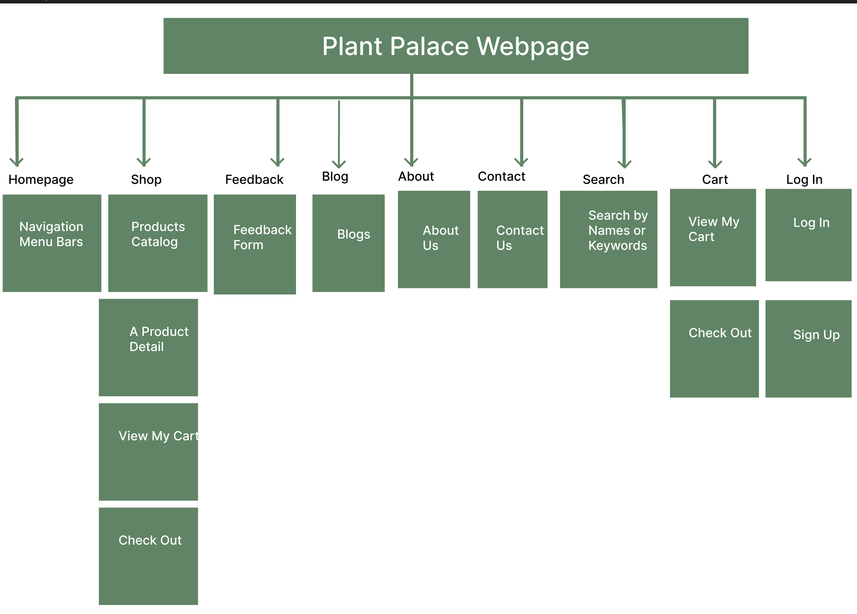

# Data Flow Diagram

The figure below shows the Data Flow Diagram identified for Plant Palace

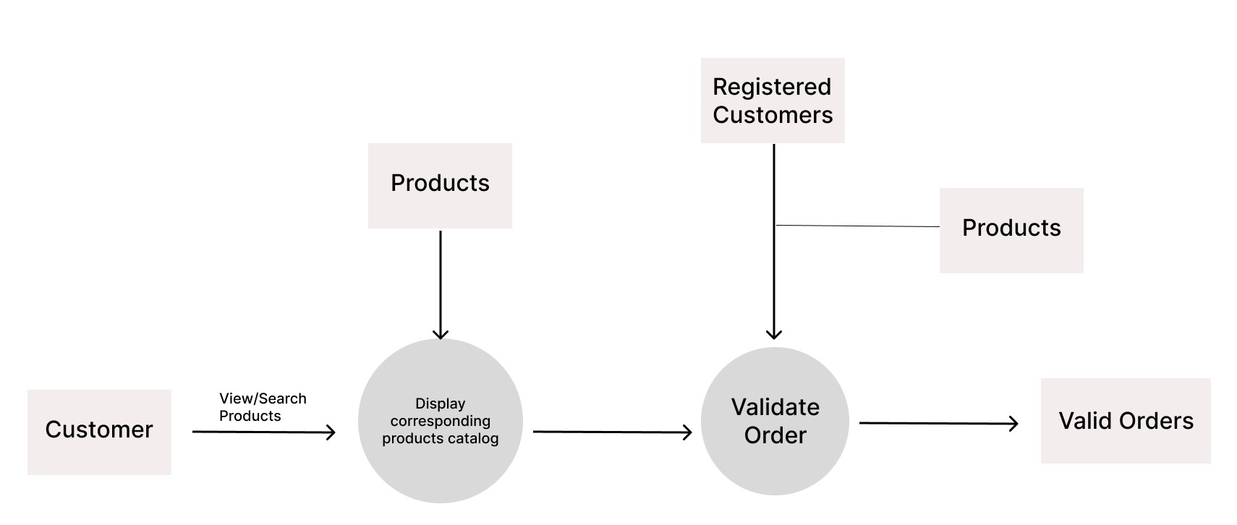

V 1.0 Aptech Ltd

# Evaluation/Testing

Below are the common use cases:

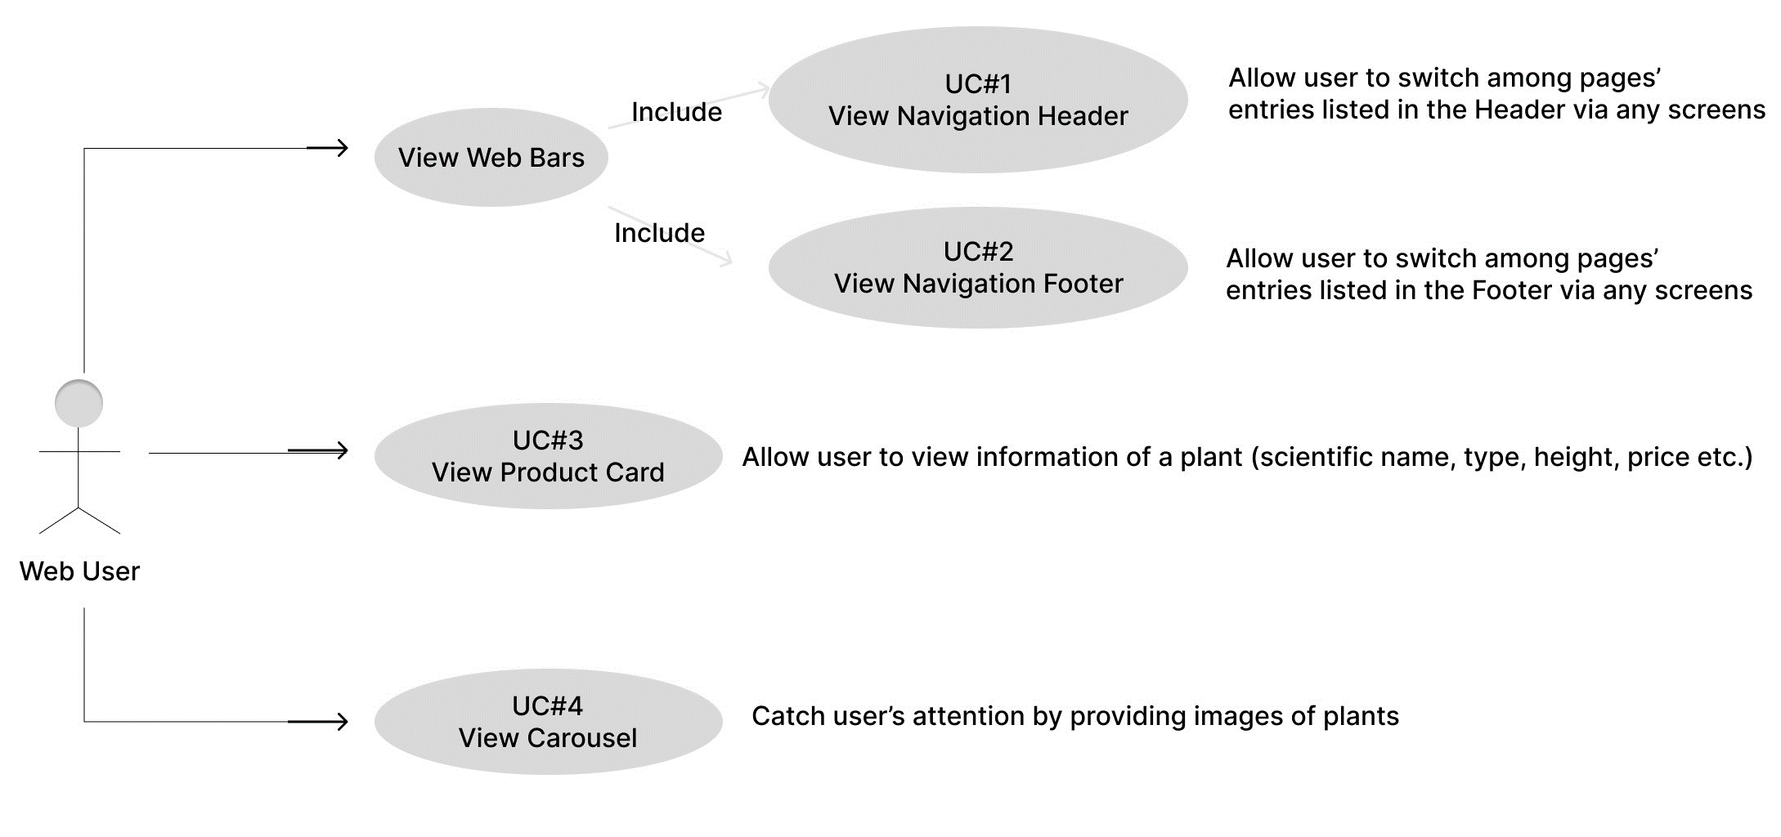

**Common Use Cases Description:**

UC#1: Common-View Navigation Header

|  |  |
| --- | --- |
| Path | User accesses the webpage  User view Menu entries in the Header  User interacts with entries via any URL |
| Pre-conditions | None |
| Trigger | On Click |
| Post-condition | System always displays the navigation header with all entries enabled  On click each entry of the menu, system navigates user to the corresponding page |









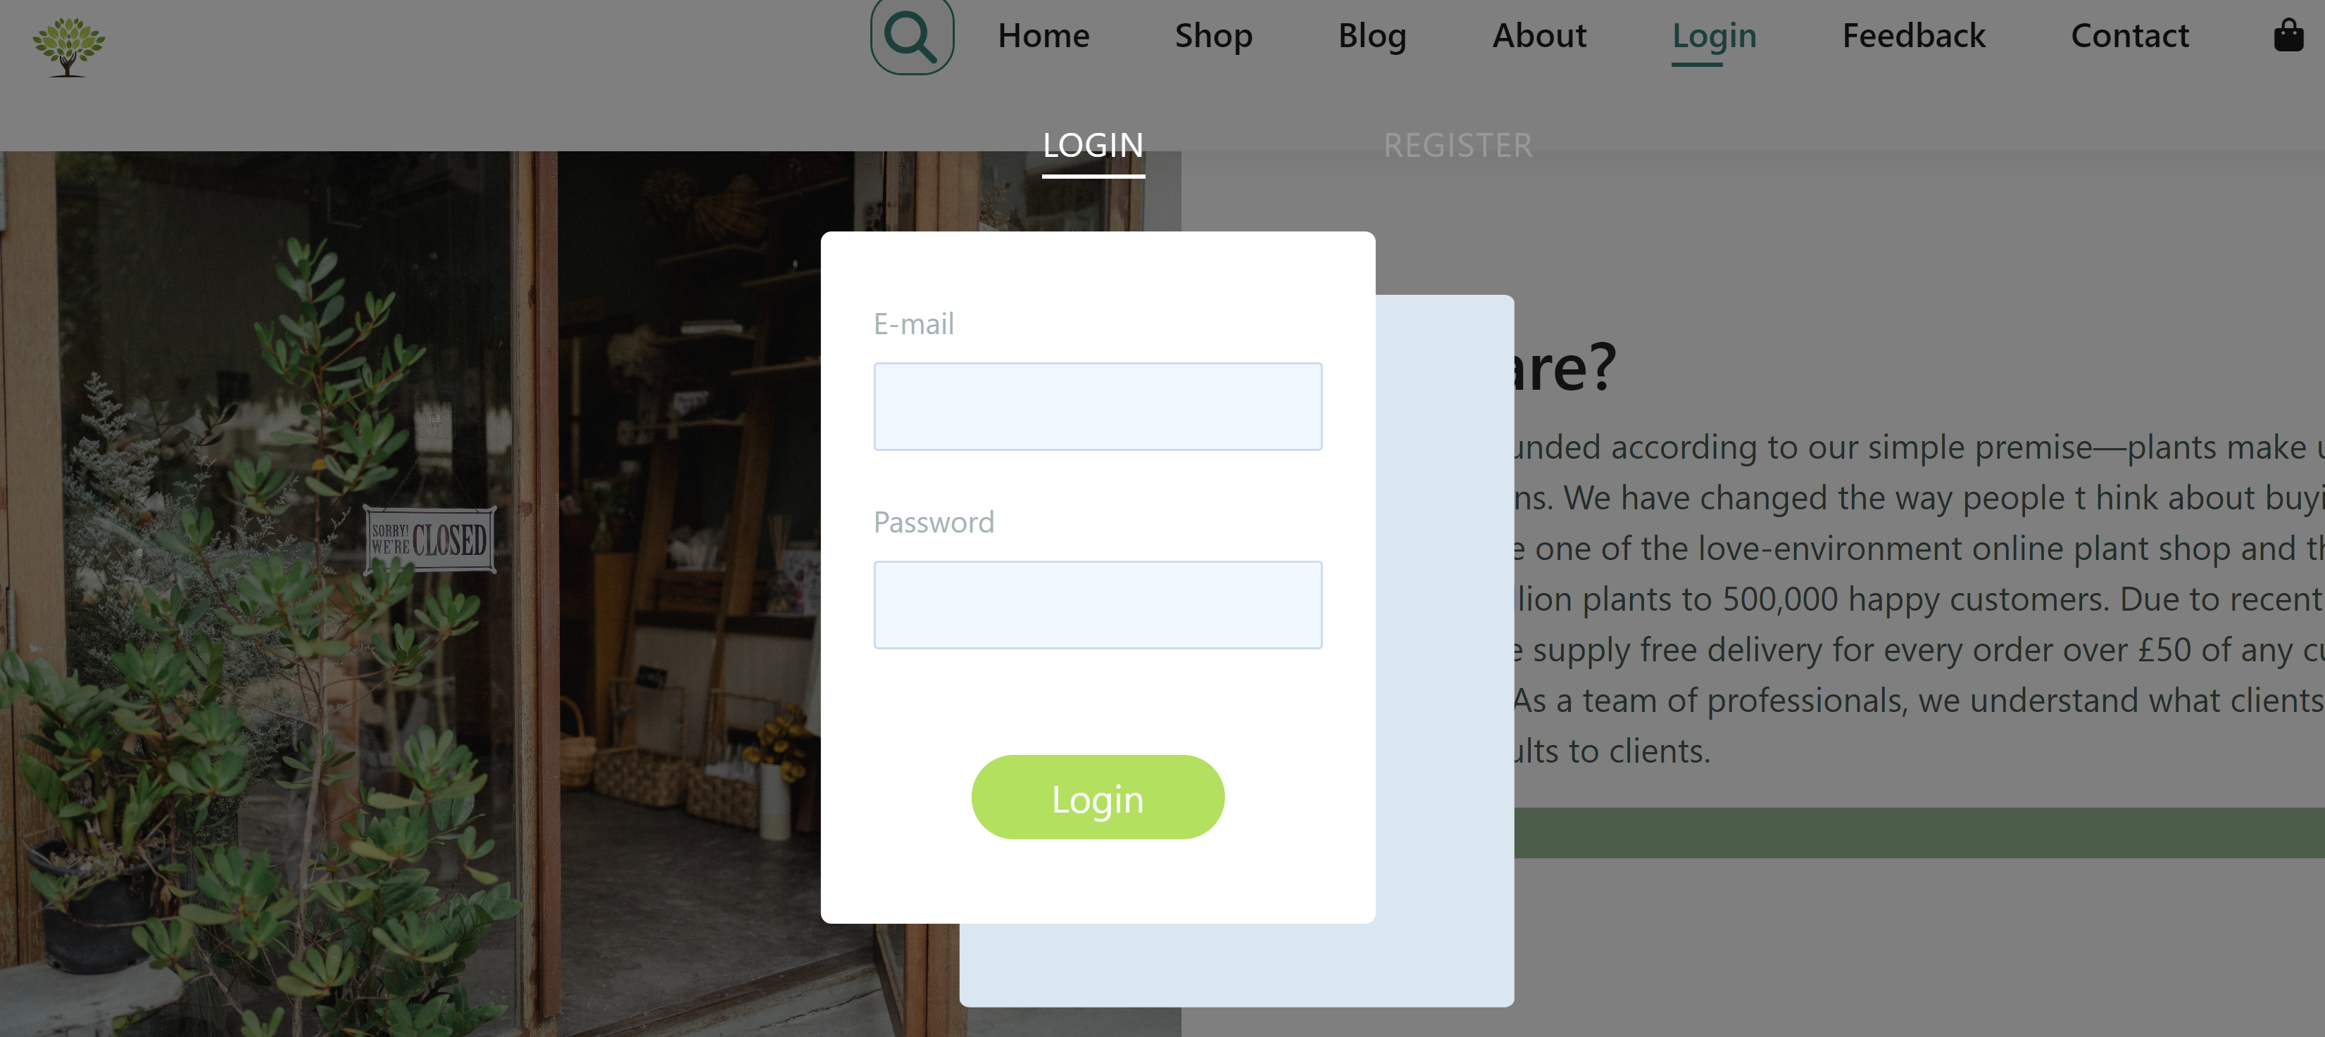









|  |  |  |  |  |  |
| --- | --- | --- | --- | --- | --- |
| Field Name | Control Format | Validation Rule | Data Type | Default Value | Trigger Event |
| The Header bar | <section> | Background-color: rgb(255, 255, 255) | - | - | - |
| Plant Palace Logo | Image | - | PNG | Enabled | On Click |
| Home | Cell (Label) | Open the Homepage | Text |
| Plants | Open the Products page |
| Feedback | Open the Feedback page |
| About | Open the About page |
| Contact | Open the Contact page |
| Search Icon | Icon | Open the Search bar | - |
| Cart Icon | Icon | Open the View My Cart page | - |
| Login Button | Button | Open Login and Register page | - |

UC#2: Common-View Navigation Footer

|  |  |
| --- | --- |
| Path | User accesses the webpage  User entries in the Footer  User interacts with entries via any URL |
| Pre-conditions | None |
| Trigger | On Click |
| Post-condition | System displays the navigation footer across the system pages with some entries,  that are feasible in this plant nursery website, are enabled. |

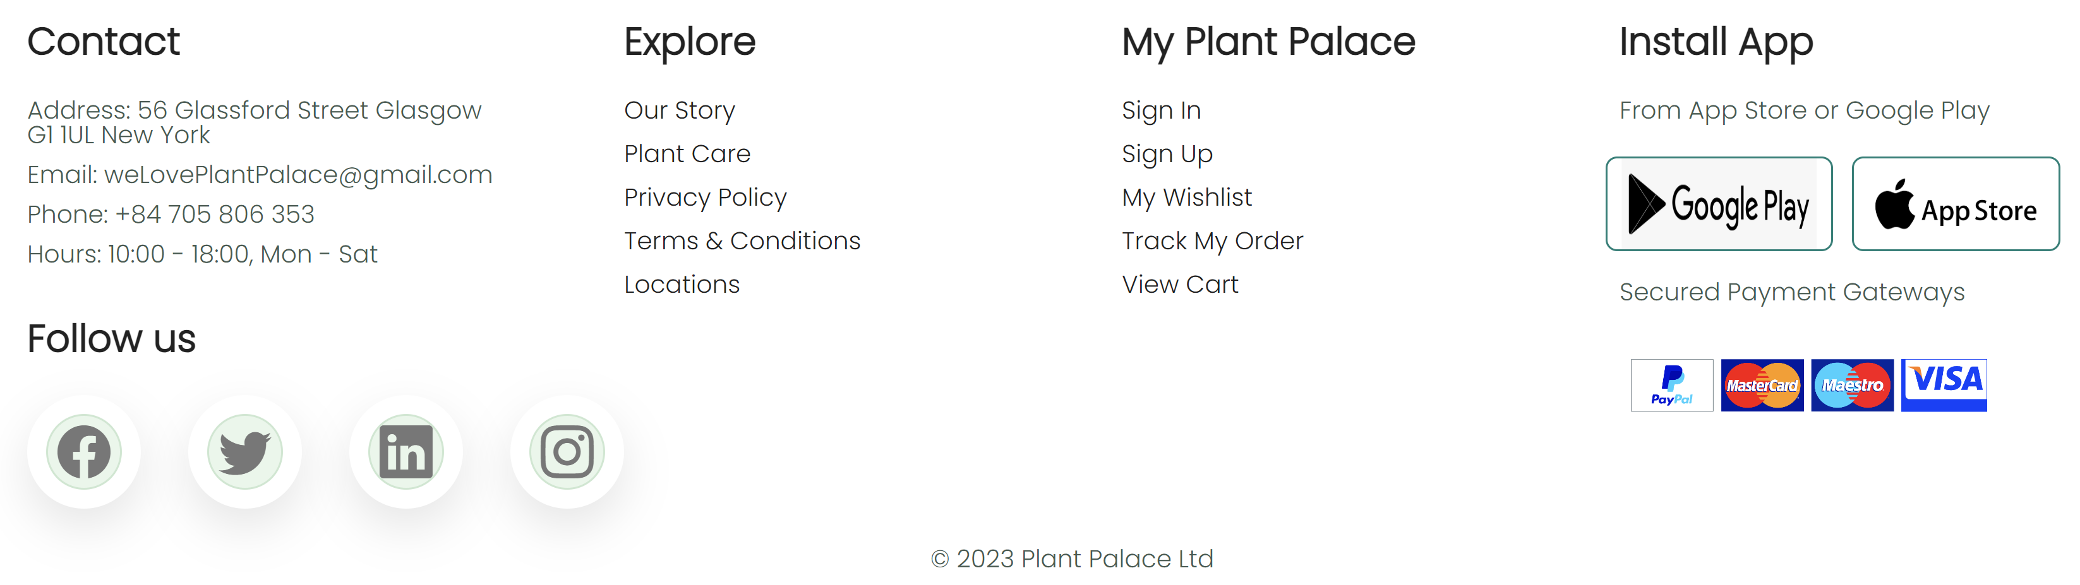

|  |  |  |  |  |  |
| --- | --- | --- | --- | --- | --- |
| Interactive Fields Name | Control Format | Validation Rule | Data Type | Default Value | Trigger Event |
| Our Story | Hyperlink Text | System opens the About Us page | - | - | - |
| Plant Care | System opens the Blogs page | PNG | Enabled | On Click |
| Privacy Policy | - | Text |
| Terms & Conditions | - |
| Locations | System opens the Contact Us page with the mini map of the store |
| Sign In | System opens the Log In page |
| Sign Up | System opens the Register page |
| My Wishlist | - |
| Track My Order | - |
| View Cart | System opens the View My Cart page |

UC#3: Common-View Product Card

|  |  |
| --- | --- |
| Path | 1: User view product card in Homepage  2. User views in Product Catalog |
| Pre-conditions | None |
| Trigger | - |
| Post-condition | Product cards are displayed row by row in applicable areas |

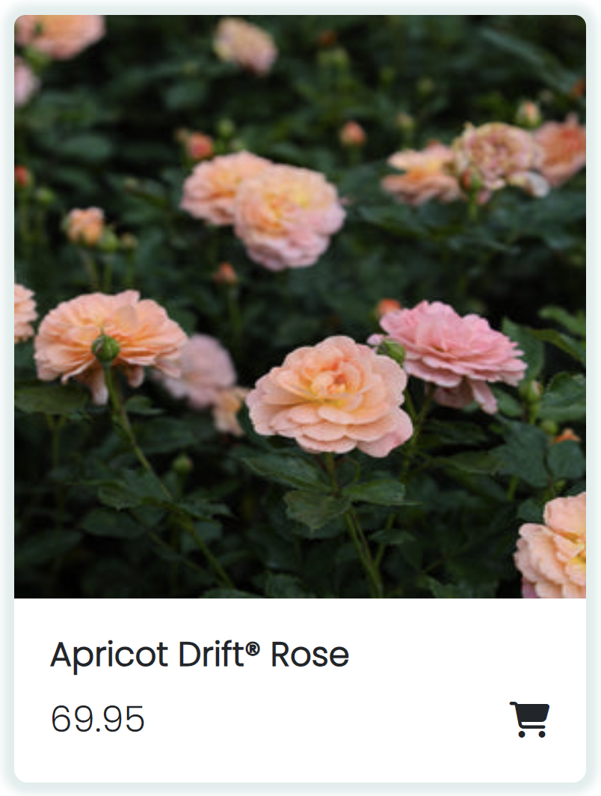

|  |  |  |  |  |  |
| --- | --- | --- | --- | --- | --- |
| Field Name | Control Format | Validation Rule | Data Type | Default Value | Trigger Event |
| <category> | Cell (Label) | Display category of each  plant | Text | - | - |
| <name> | Cell (Label) | Display name of each plant | Text | - | - |
| <price> | Cell (Label) | Display the price of each plant | CHAR | - | - |
| Cart icon | Icon | On hover, change to another icon as below    On click, system add the product to the cart | Icon | - | On Click |

UC#4: Common-View Web Carousel

|  |  |
| --- | --- |
| Path | User accesses the Homepage |
| Pre-conditions | None |
| Trigger | On click |
| Post-condition | System displays the carousel with several images |

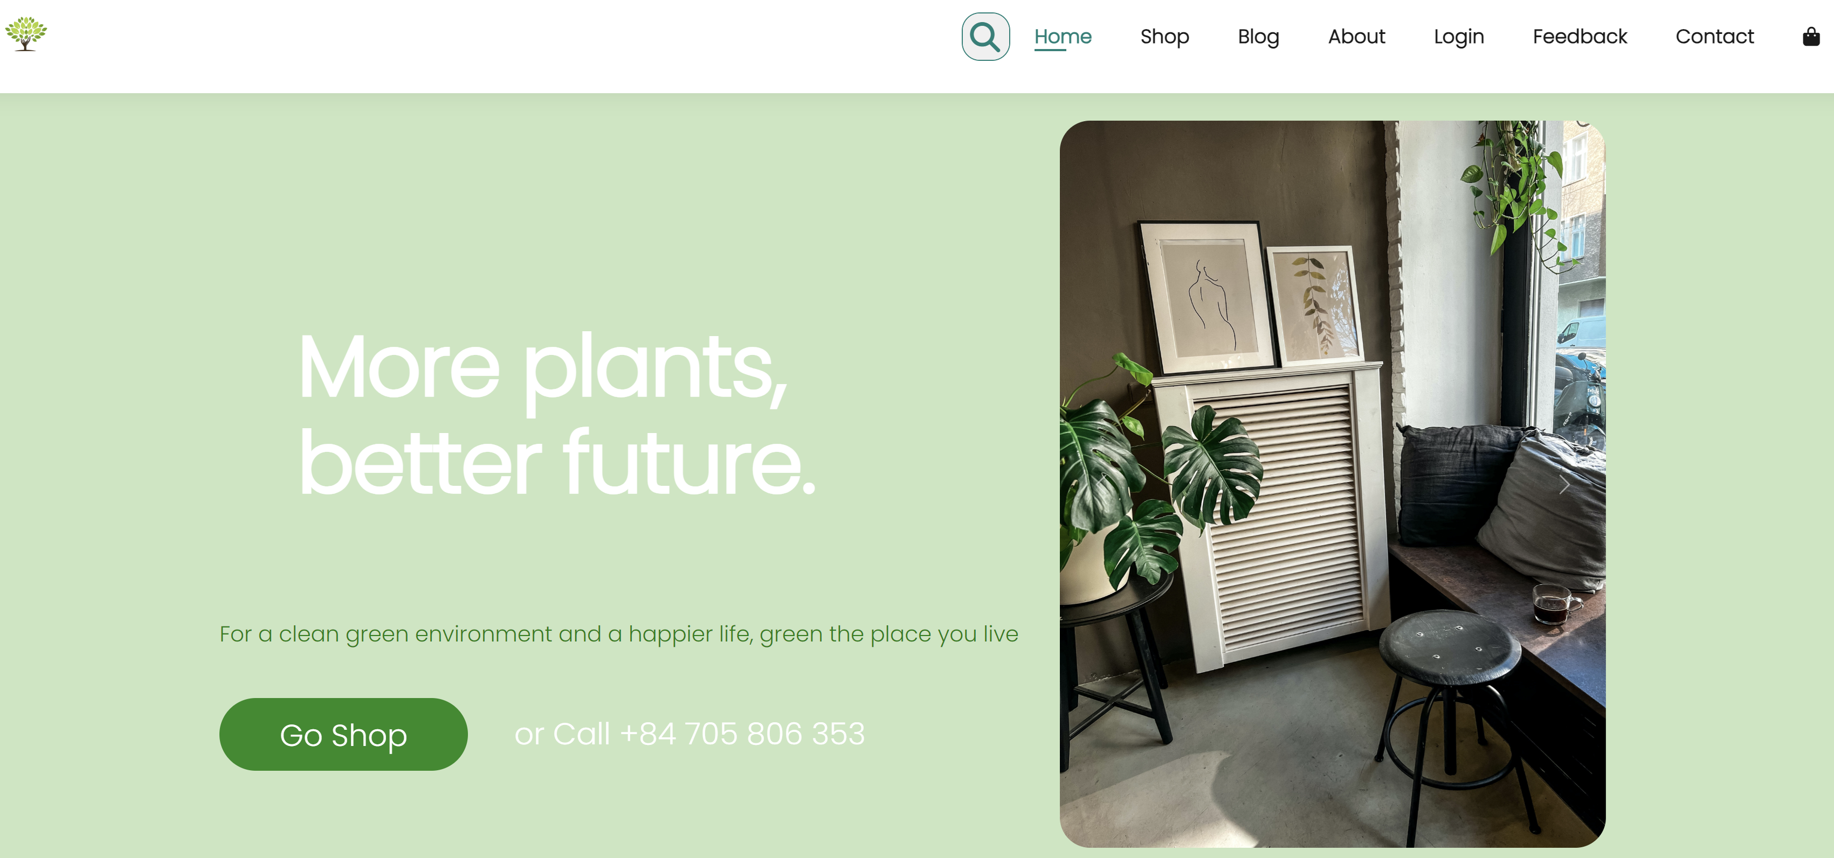

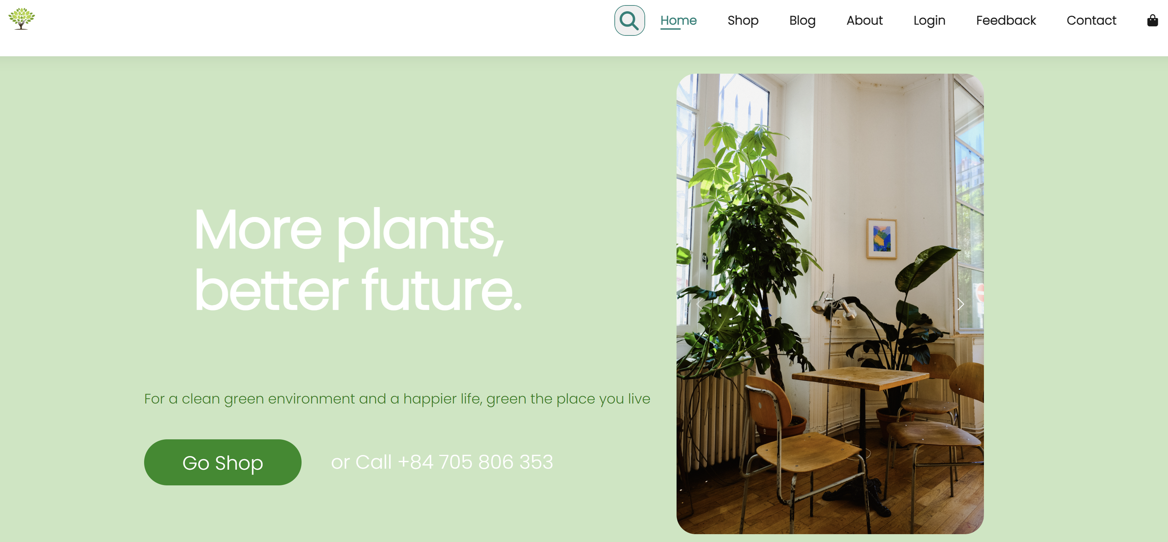

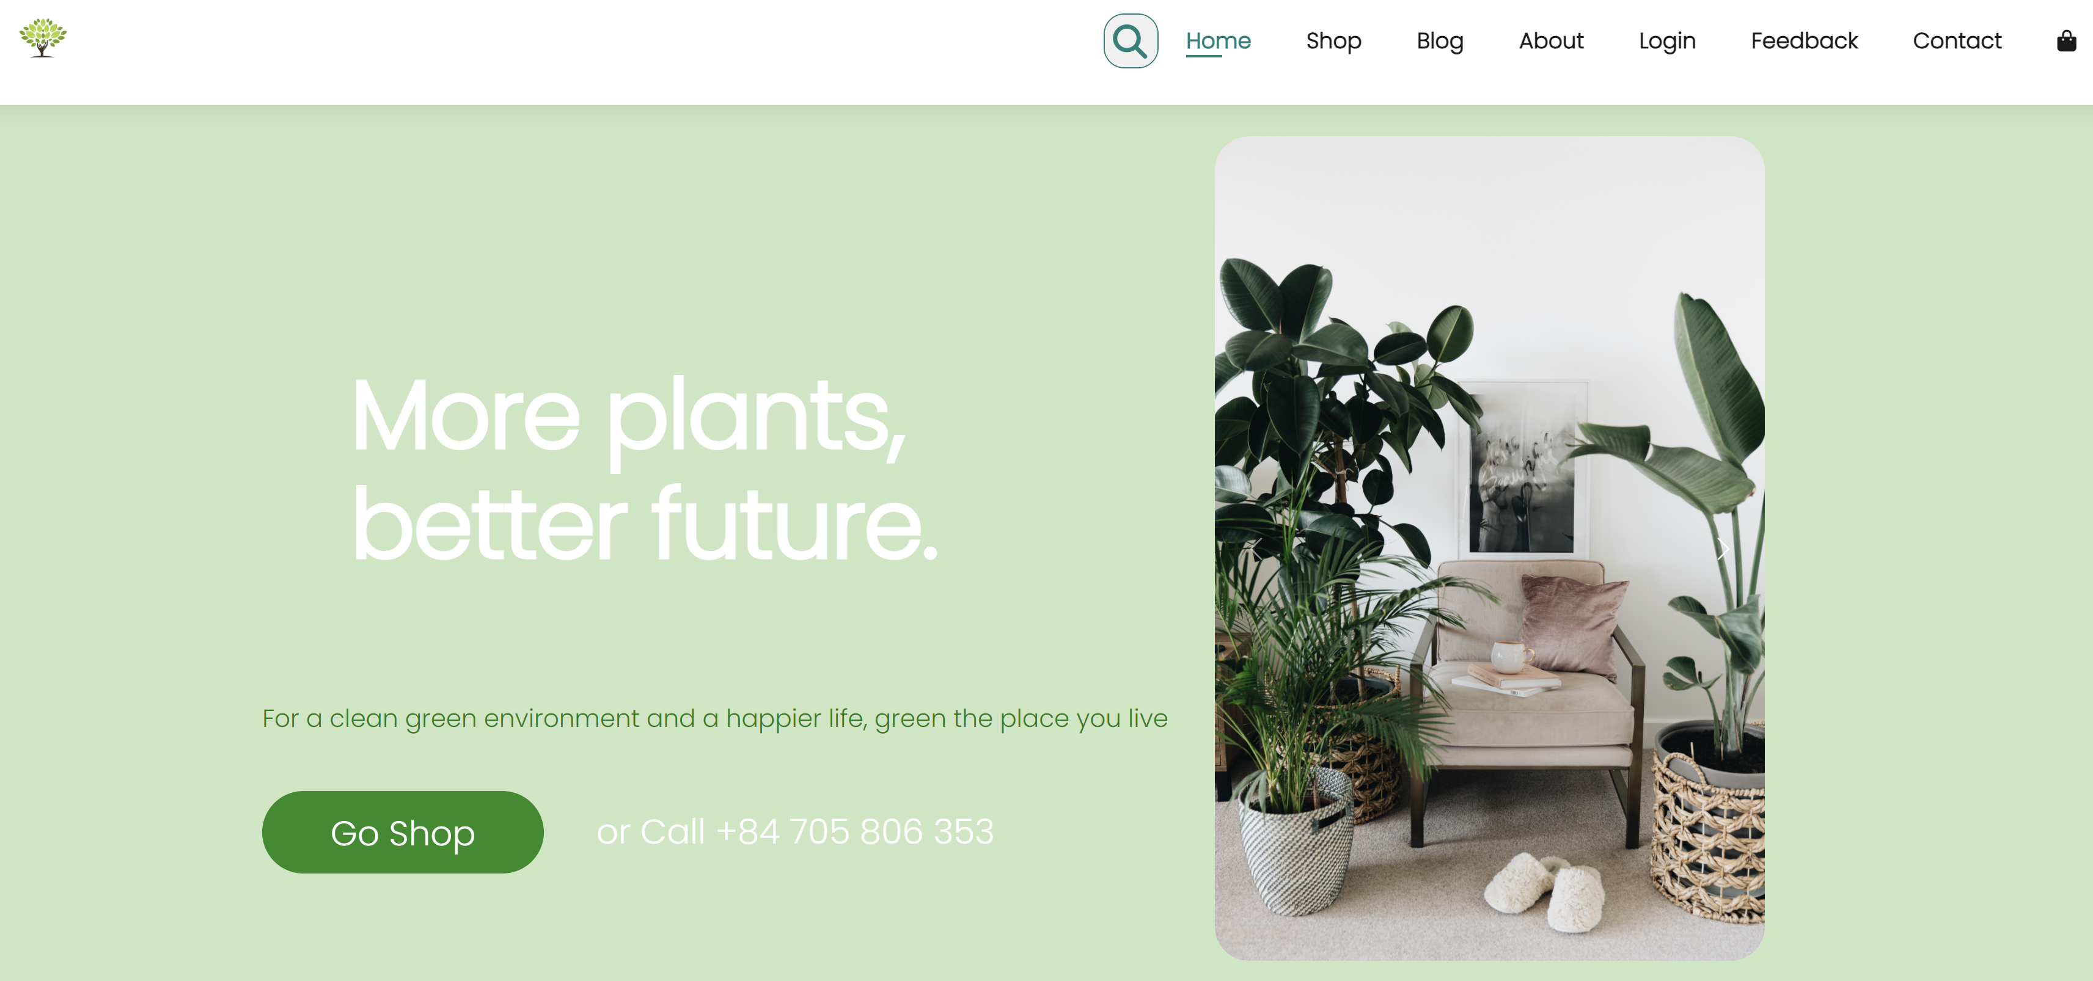

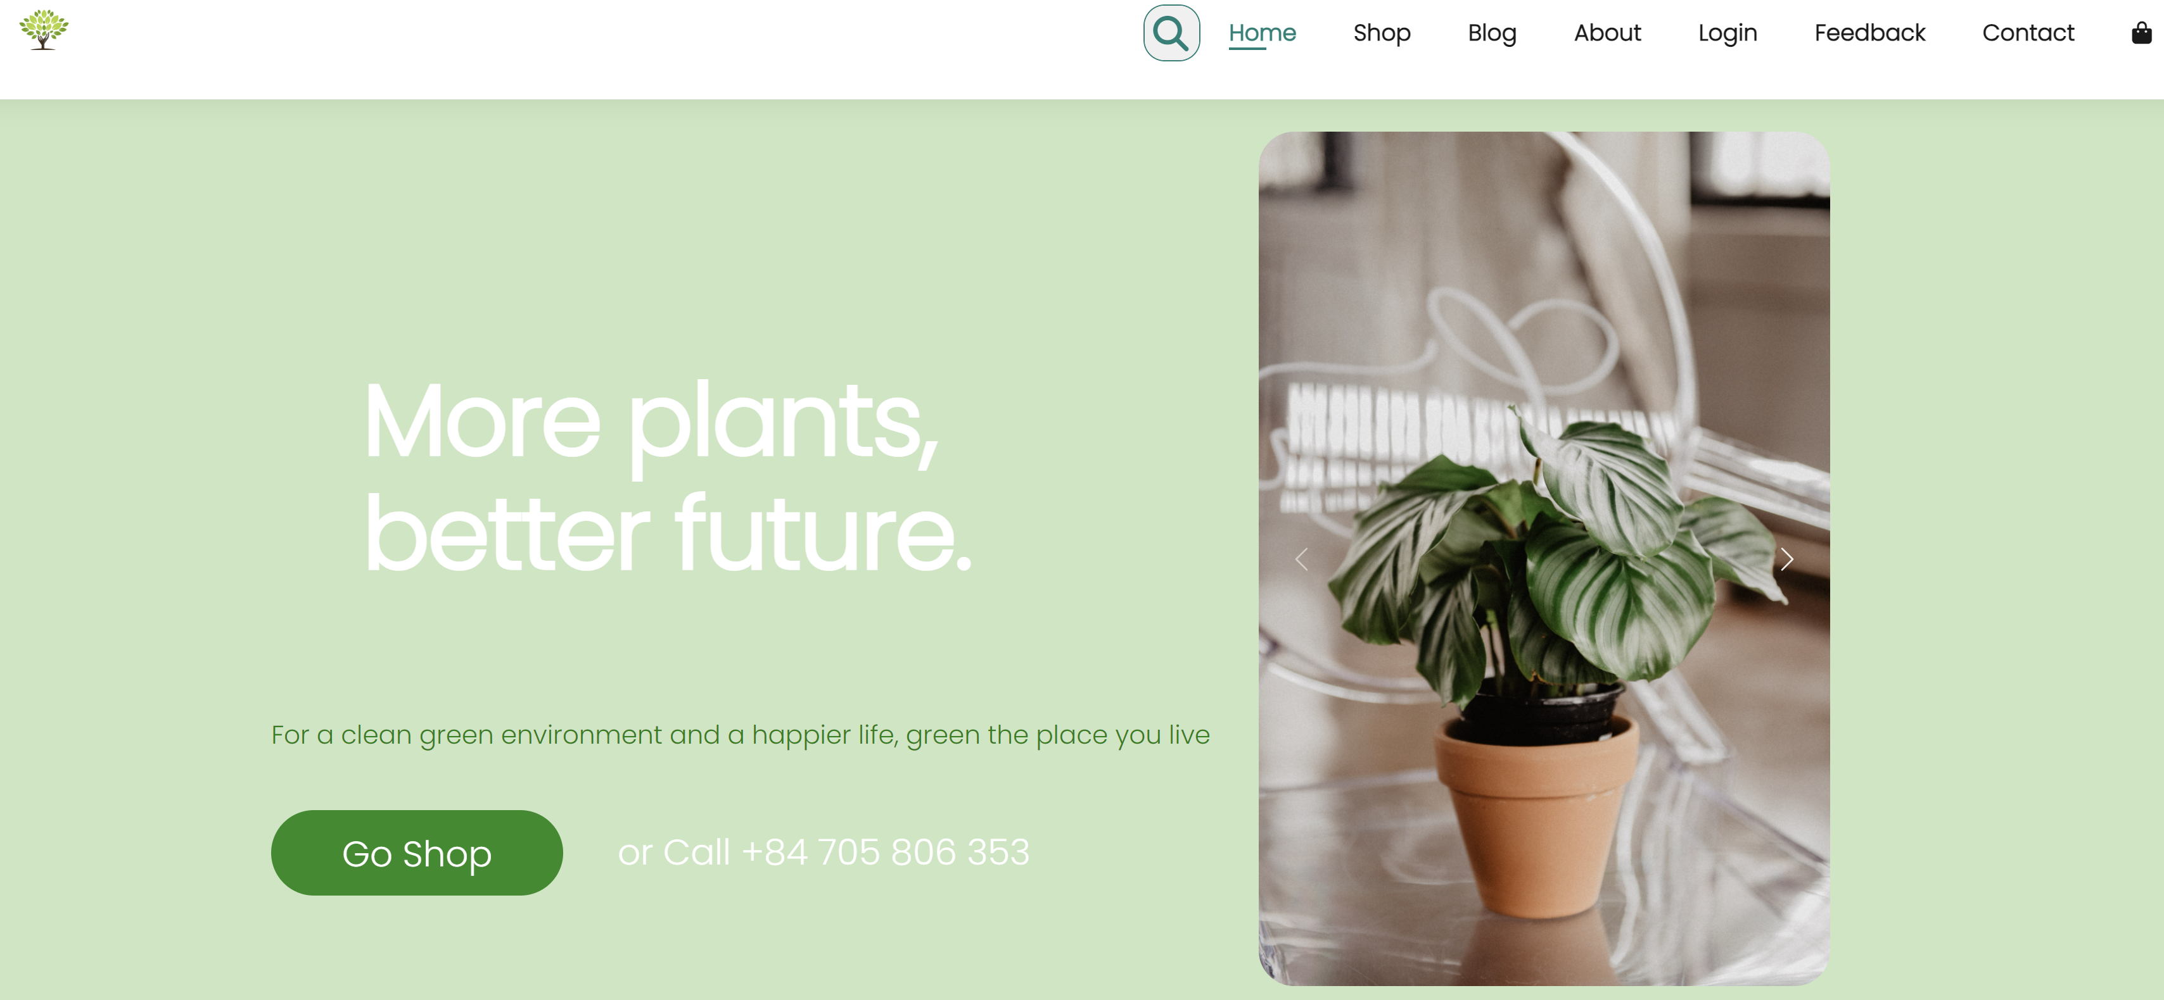

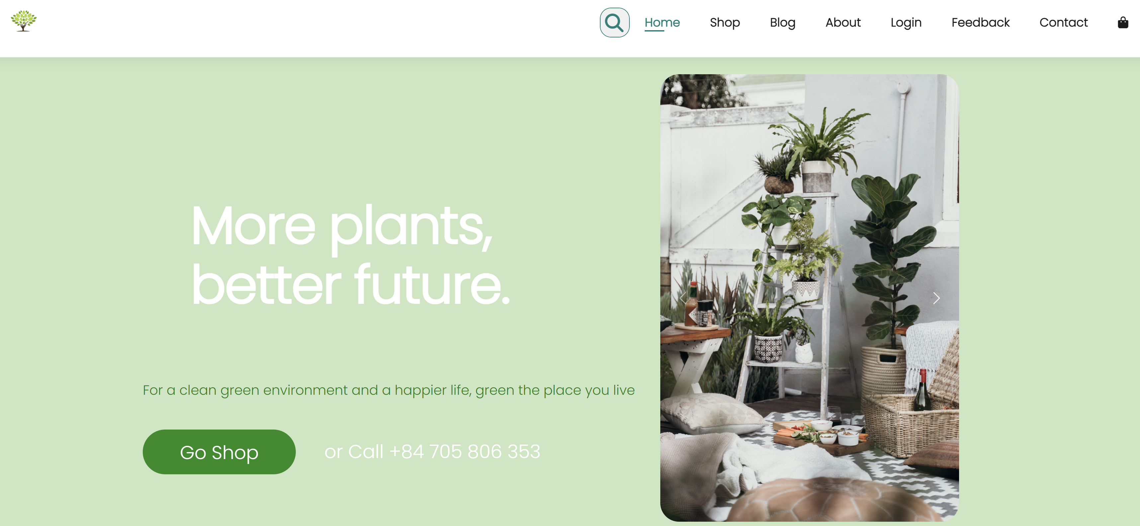

|  |  |  |  |  |  |
| --- | --- | --- | --- | --- | --- |
| Field Name | Control Format | Validation Rule | Data Type | Default Value | Trigger Event |
| Carousel | Images | Display category of each  plant | PNG | - | On click |
| Text | Paragraph | Display name of each plant | Text | - | - |
| Go Shop button | Button | Navigate user to Products page | - | Enabled | On click |

**Plant Palace Self-Introduction**



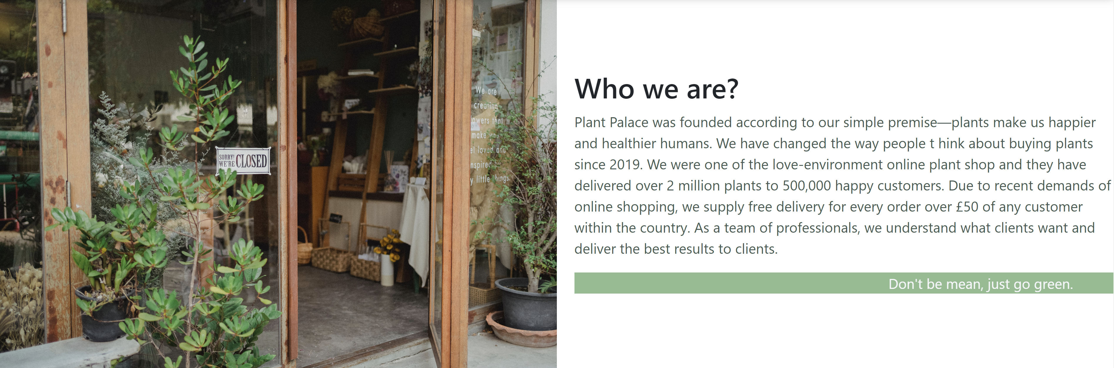



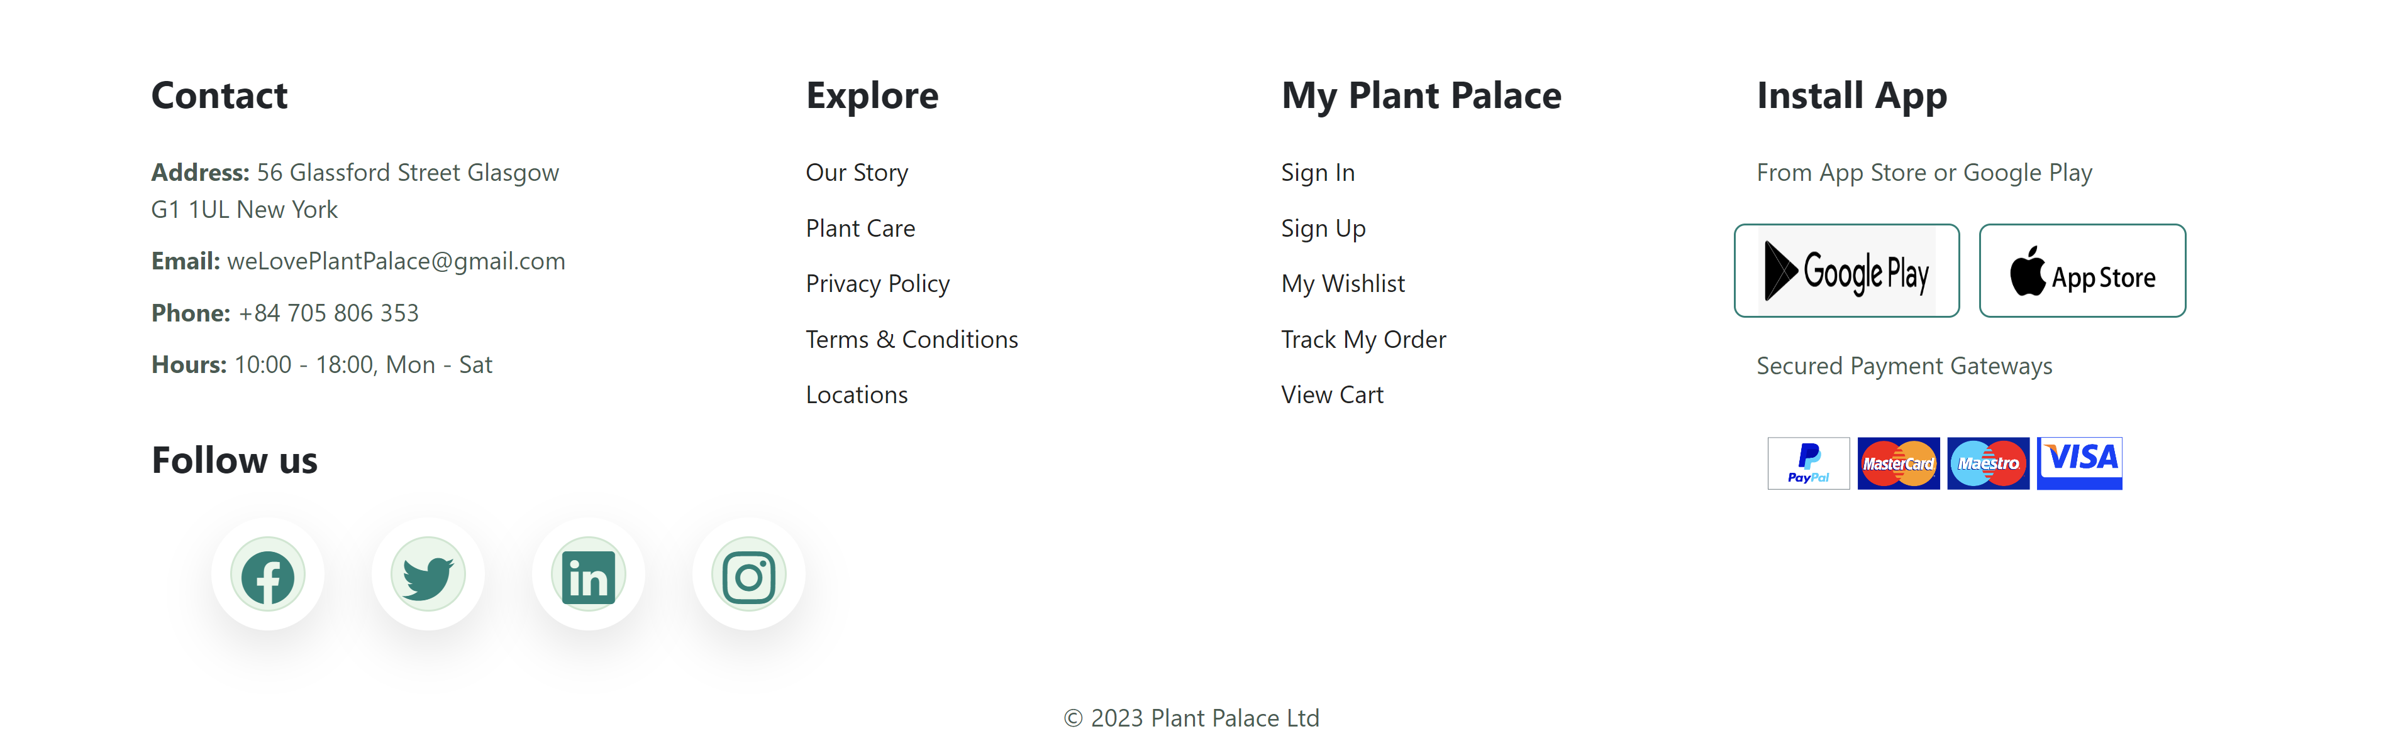

|  |  |  |  |  |  |
| --- | --- | --- | --- | --- | --- |
| Field Name | Control Format | Validation Rule | Data Type | Default Value | Trigger Event |
| <image> | Image | Image inserted, refer to  ./img/aboutUs.png | PNG | Displayed | - |
| <introduction text> | <p> | Display the paragraph text:  “Plant Palace was founded according to our simple premise—plants make us happier and healthier humans. We have changed the way people think about buying plants since 2019. We were one of the love-environment online plant shop and they have delivered over 2 million plants to 500,000 happy customers.  Due to recent demands of online shopping, we supply free delivery for every order over £50 of any customer within the country. As a team of professionals, we understand what clients want and deliver the best results to clients. | Text | Displayed | - |
| Carousel | Images | Display plants’ gallery | PNG | Displayed | On click |

**Log In/Register**

Process Flows

The figure below shows the Register flow identified for the system

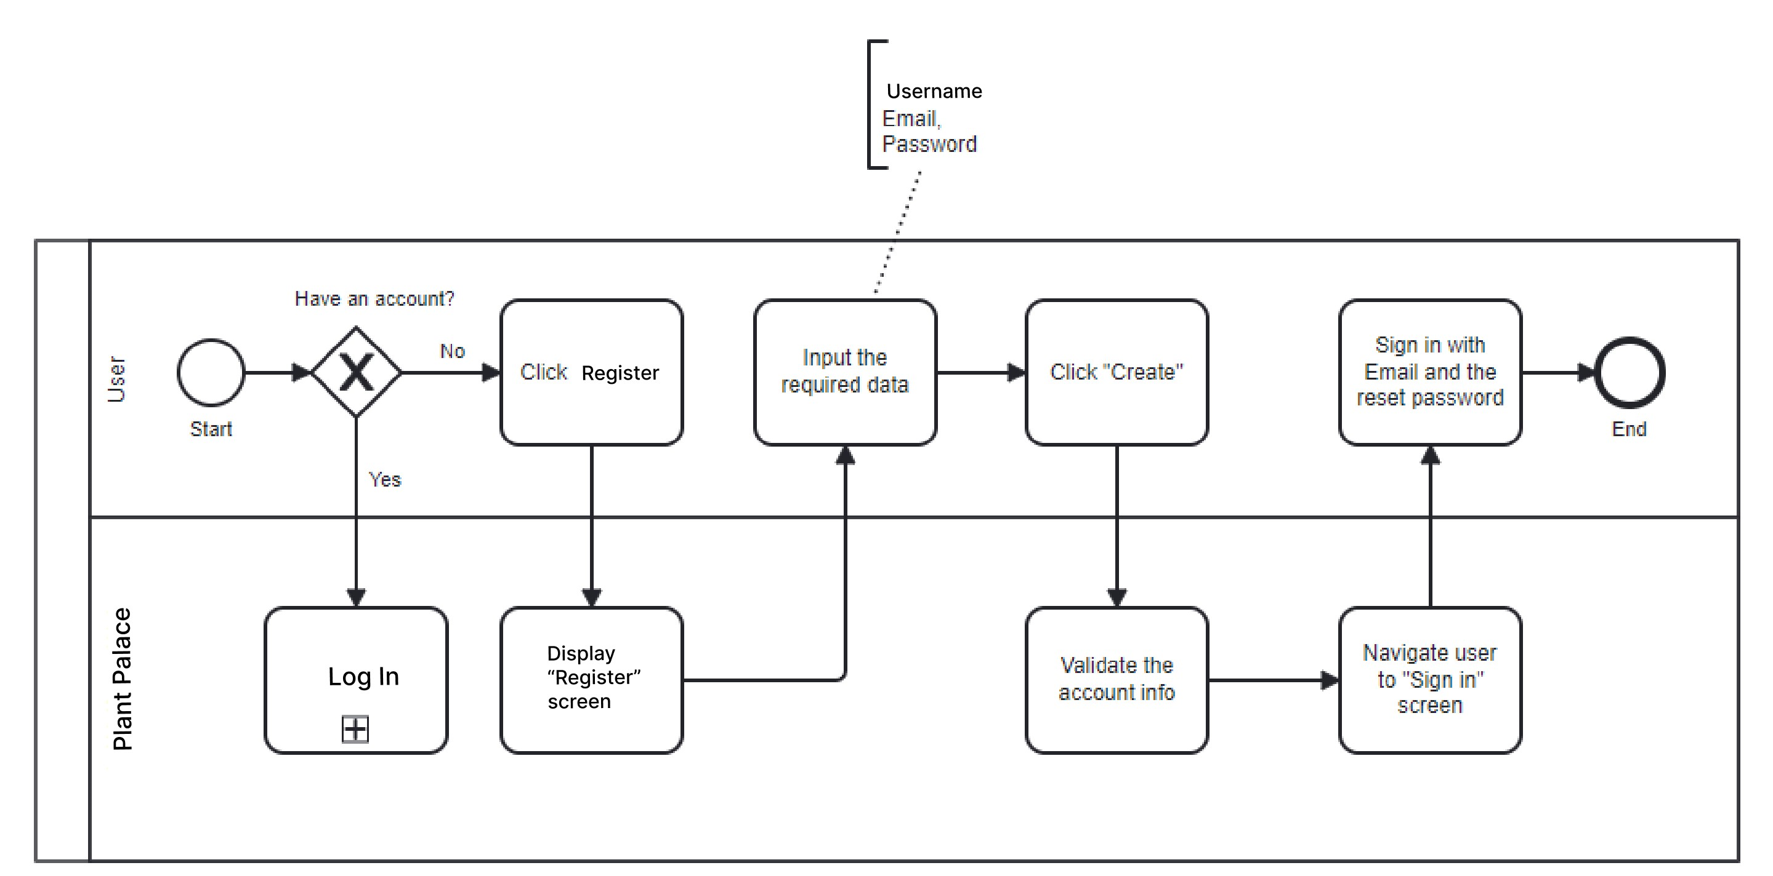

The figure below shows the Log In flow identified for the system

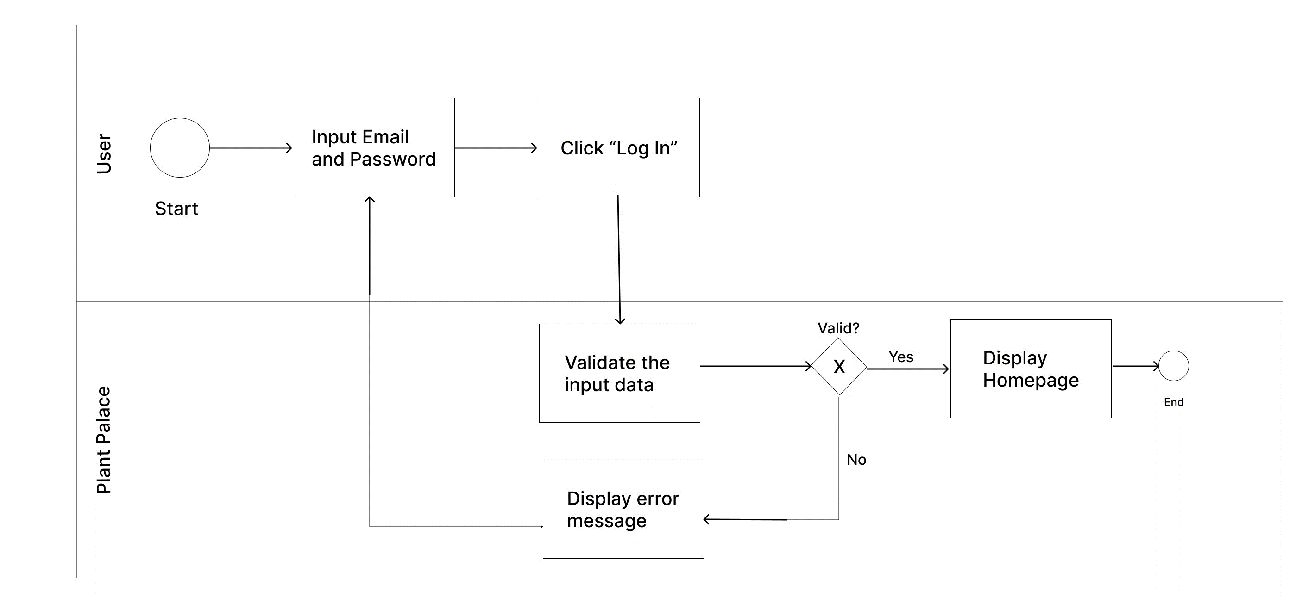

**Use Cases**

|  |  |  |
| --- | --- | --- |
| # | UC Name | Description |
| 5 | Log In | Allows user to log into Plant Palace with corresponding user email and  password |
| 6 | Register | Allows user to create a new account to log into Plant Palace |

**Use Case Description:**

UC#5: Log In

|  |  |
| --- | --- |
| Path | 1: User accesses Log In screen via any URL of the system (Footer >> Sign In) or user is requested to Log In upon checking out his/her shopping cart.  2. User inputs his or her Email and Password to log into the system. |
| Pre-conditions | User account is setup successfully  The password must be valid |
| Trigger | Login button On Click |
| Post-condition | Success:  System send Success Response and redirect users to the Homepage with user’s  corresponding username.  Fail: (This is one of our wish-list features that do not have enough time to consistently implemented)  Display Error Messages:  “Email and Password are not valid.” |



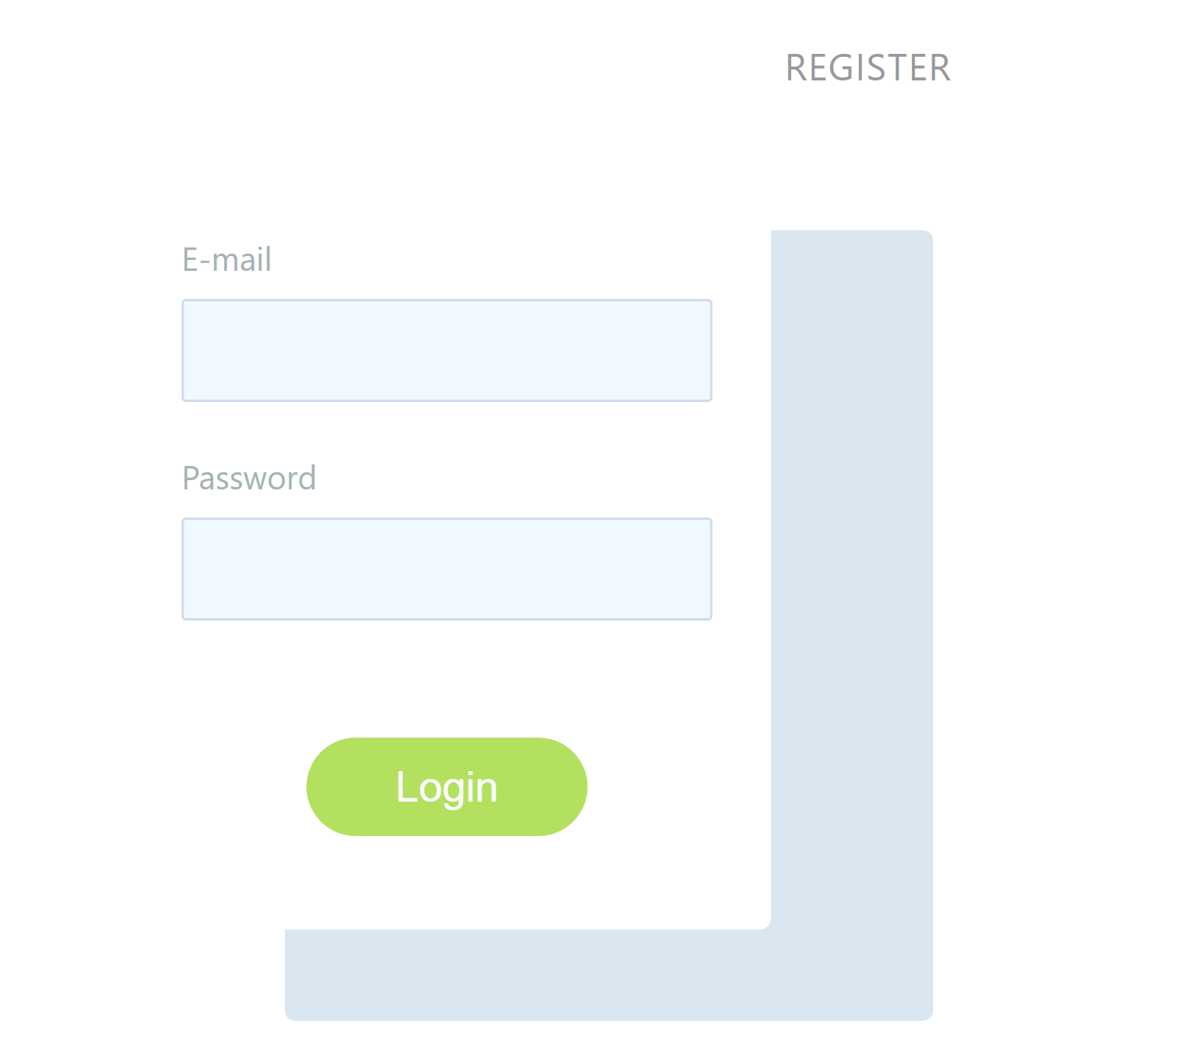

|  |  |  |  |  |  |
| --- | --- | --- | --- | --- | --- |
| Field Name | Control Format | Validation Rule | Data Type | Default Value | Trigger Event |
| Login | Cell(Label) | Hidden “Login” text | PNG | Hidden | - |
| Email | Input Field | Be mandatory and user editable  Must be in email format (…@...) | Email | Display placeholder:  Email | On each  character  typing |
| Password | Input Field | Accept free text input  Be mandatory and user editable | Free text | Display  placeholder:  Password | On each character  typing |
| Login | Button | System prompts the success response “Create Account successfully!” | Text | - | On Click |

UC#6: Register

|  |  |
| --- | --- |
| Path | User accesses Register via Log In screen  User is requested to have an account to continue.  User inputs his or her Username, Email and Password to create his or her  new account. |
| Pre-conditions | None |
| Trigger | Register button On Click |
| Post-condition | Success:  System send Success Response and redirect users to the Log In page.  Fail: (This is also our wish-list feature)  Display Error Responses “Account Not Created” |



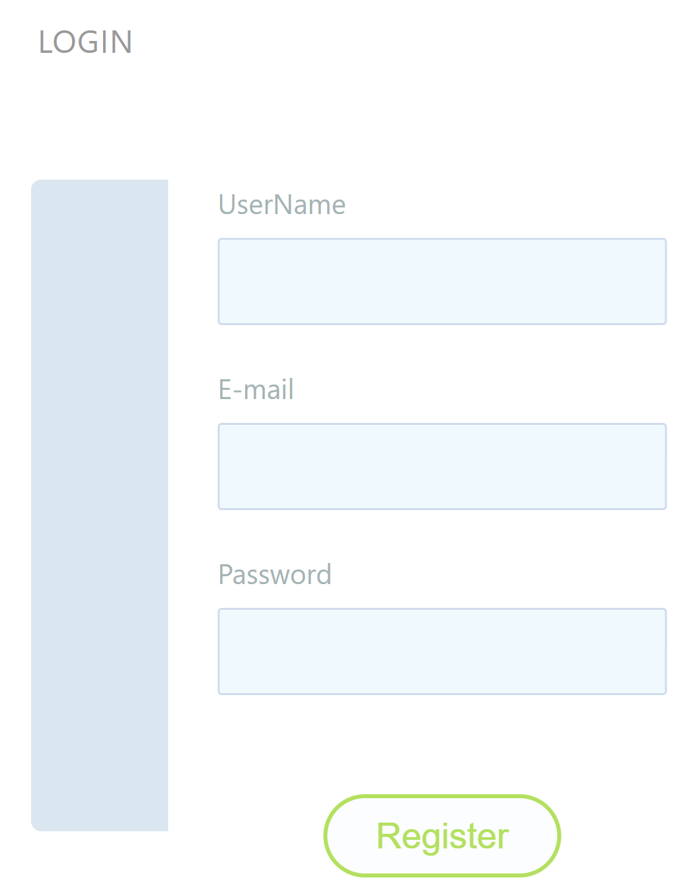

|  |  |  |  |  |  |
| --- | --- | --- | --- | --- | --- |
| Field Name | Control Format | Validation Rule | Data Type | Default Value | Trigger Event |
| Login | Cell(Label) | Hidden “Login” text | PNG | Hidden | - |
| Email | Input Field | Accept free text input  Be mandatory and user editable  Must be in email format (…@...) | Text | Display placeholder:  Email | On each  character  typing |
| Password | Input Field | Accept free text input  Be mandatory and user editable | Free text | Display  placeholder:  Password | On each character  typing |
| Login | Button | System prompts the success response “Create Account successfully!” | Text | - | On Click |

UC#7: Feedback



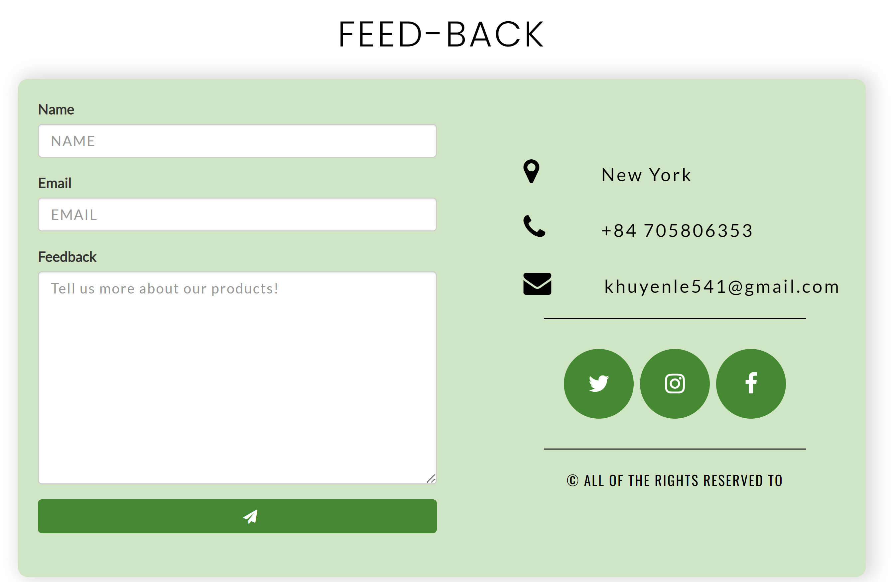

|  |  |
| --- | --- |
| Path | User accesses Feedback through the Navigation bar or Customer Support Consulting  User inputs his or her Username, Email and Feedback to complete his or her  Feedback form. |
| Pre-conditions | None |
| Trigger | Send button On Click |
| Post-condition | (These are also our wish-list features)  Success:  System send Feedback Success to the user.  Fail:  In case of blank text, display Error Responses “Please fill all the content.” |

|  |  |  |  |  |  |
| --- | --- | --- | --- | --- | --- |
| Field Name | Control Format | Validation Rule | Data Type | Default Value | Trigger Event |
| Name | Input Field | Display user’s name | Text | Display placeholder:  Name | On each  character  typing |
| Email | Input Field | Accept free text input  Be mandatory and user editable  Must be in email format (…@...) | Text | Display placeholder:  Email | On each  character  typing |
| Feedback | Input Field | Accept free text input  Be mandatory and user editable | Free text | Display  placeholder:  Password | On each character  typing |
| Send | Button | System prompts the success response “Feedback Success!” | - | - | On click |

# Project Tracking and Monitoring Activities

Review has been conducted time to time to monitor project status.

# Documentation Section

<All filled up forms>

# Source Code

* AJAX:

https://ajax.googleapis.com/ajax/libs/angularjs/1.6.9/angular.min.js

https://ajax.googleapis.com/ajax/libs/angularjs/1.6.9/angular-route.js

* Font Awesome:

https://cdnjs.cloudflare.com/ajax/libs/font-awesome/6.4.2/css/all.min.css

* Bootstrap5 cdn:

"https://cdn.jsdelivr.net/npm/bootstrap-icons@1.10.5/font/bootstrap-icons.css

# User Guide

The Website will be hosted on a local Web server and will be tested on all latest and popular browsers such as IE, Opera, and Chrome. The requirements on the client machine include Pentium 4 or higher processor, 1 GB or higher RAM, and a compatible browser to view the Website.

*~~ End ~~*

V 1.0 Aptech Ltd